Father’s Heart In Aspirations
Intro – 3-4 sentences on each bubble
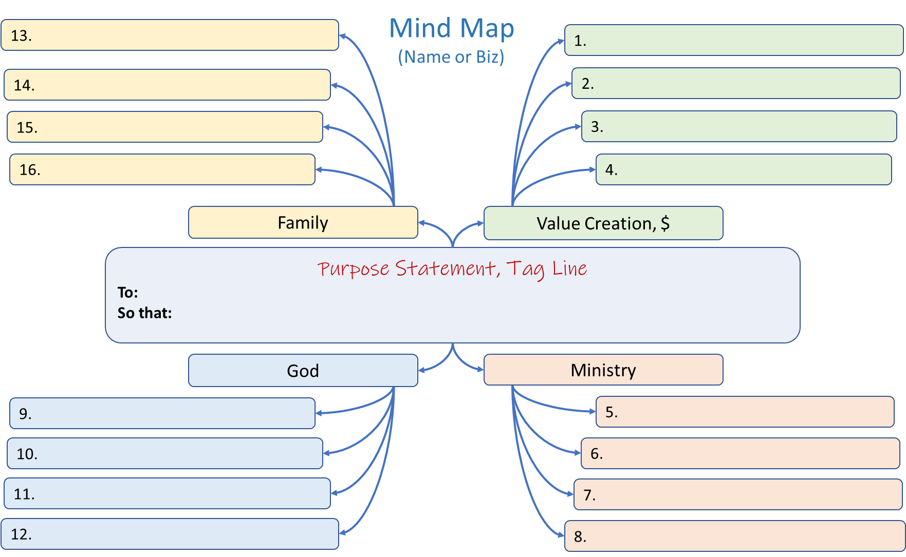
- –

Goals – where will I be  (Looking back from future) | “Emotional Why” (How it will feel?) “Vision” - what does it look like? | What’s the Next Step?

- –

Goals – where will I be  (Looking back from future) | “Emotional Why” (How it will feel?) “Vision” - what does it look like? | What’s the Next Step?

- –

Goals – where will I be  (Looking back from future) | “Emotional Why” (How it will feel?) “Vision” - what does it look like? | What’s the Next Step?

- –

Goals – where will I be  (Looking back from future) | “Emotional Why” (How it will feel?) “Vision” - what does it look like? | What’s the Next Step?

- –

Goals – where will I be  (Looking back from future) | “Emotional Why” (How it will feel?) “Vision” - what does it look like? | What’s the Next Step?

- –

Goals – where will I be  (Looking back from future) | “Emotional Why” (How it will feel?) “Vision” - what does it look like? | What’s the Next Step?

- –

Goals – where will I be  (Looking back from future) | “Emotional Why” (How it will feel?) “Vision” - what does it look like? | What’s the Next Step?

- –

Goals – where will I be  (Looking back from future) | “Emotional Why” (How it will feel?) “Vision” - what does it look like? | What’s the Next Step?

- –

Goals – where will I be  (Looking back from future) | “Emotional Why” (How it will feel?) “Vision” - what does it look like? | What’s the Next Step?

- –

Goals – where will I be  (Looking back from future) | “Emotional Why” (How it will feel?) “Vision” - what does it look like? | What’s the Next Step?

- –

Goals – where will I be  (Looking back from future) | “Emotional Why” (How it will feel?) “Vision” - what does it look like? | What’s the Next Step?

- –

Goals – where will I be  (Looking back from future) | “Emotional Why” (How it will feel?) “Vision” - what does it look like? | What’s the Next Step?

- –

Goals – where will I be  (Looking back from future) | “Emotional Why” (How it will feel?) “Vision” - what does it look like? | What’s the Next Step?

- –

Goals – where will I be  (Looking back from future) | “Emotional Why” (How it will feel?) “Vision” - what does it look like? | What’s the Next Step?

- –

Goals – where will I be  (Looking back from future) | “Emotional Why” (How it will feel?) “Vision” - what does it look like? | What’s the Next Step?

- –
Goals – where will I be  (Looking back from future) | “Emotional Why” (How it will feel?) “Vision” - what does it look like? | What’s the Next Step?

Goals – where will I be  (Looking back from future) | “Emotional Why” (How it will feel?)  “Vision” - what does it look like? | What’s the Next Step?
1.
2.

3.
4.
5.
6.
7.
8.
9.
10.
11.
12.
13.
14.
15.
16.

