2022-03-16 Strategy of Heaven
Father, show me the strategy of heaven; evidence of progress. We can see enemy devices and strategies (graphic and Clay Clark interview). I want equal clarity on your Kingdom, “What are you doing.”
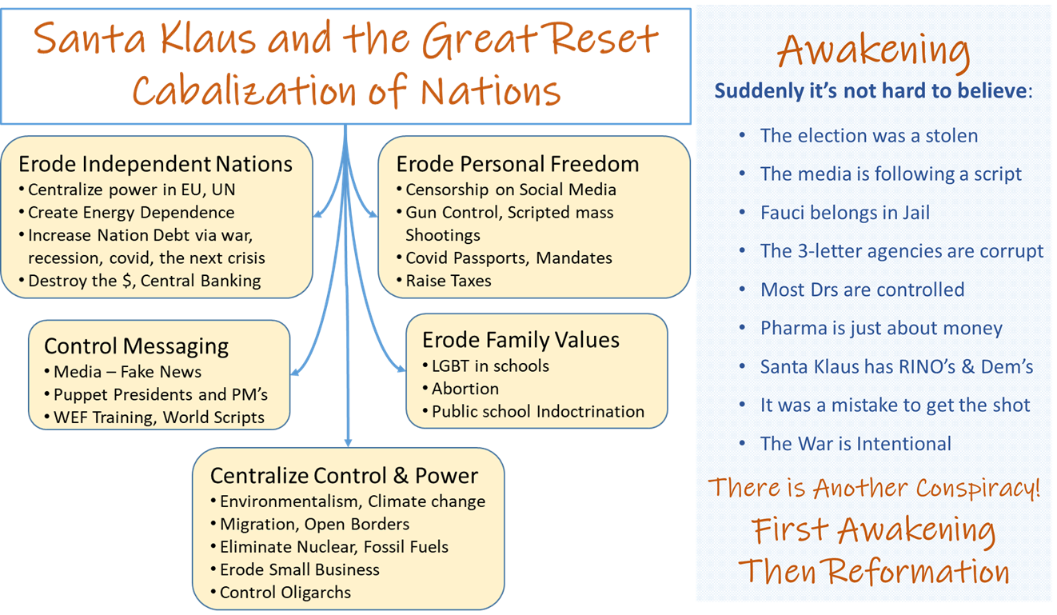
Awakening is happening – political involvement and grassroots ownership
- Sons are taking responsibility for their role (Reawaken America Events, truckers)
- Trump is a prototype of sons, not just a deliverer or savior (there are many more)
Rom 11:4-5 - "I have reserved for myself seven thousand who have not bowed the knee to Baal."
1 Chron 12:14-15 – These Gadites were army commanders; the least was a match for a hundred, and the greatest for a thousand. NIV
Businesspeople are being invited – multiplying Sons, exploits
- The goal is Intentional Reformation
Principalities are being replaced
- The weapons of warfare are the Courts and Council of heaven
- Sons are being chosen and appointed (Ezekial’s army is being assembled)
- The enemy is attacking itself (A house divided cannot stand)
Jesus 2 Chron 20:12-23
- 12. We do not know what to do, but our eyes are upon you."
- 15. the battle is not yours, but God's.
- 17. Take up your positions; stand firm and see the deliverance the Lord will give you
- 22. the Lord set ambushes against the men of Ammon and Moab and Mount Seir
- 23. they (sons) finished slaughtering the men from Seir, they helped to destroy one another. NIV
Set an Ambush, Infiltrate (Lord, what does it mean?)
- Go meet the enemy even though its larger
- Truth is a weapon, “Ambush” is decrees from Heaven.

Holy Spirit - Prophetic Decrees from heaven will not return void
- Ambush principalities with decrees (from the courts and council of heaven, not your decrees)
- The Enemy’s only power is deception (Klaus Schwab, cow burps)
- Prophetic decrees turn battles like the tides are turned
- Decrees are ambushes – lay in wait until I give the sound
2 Sam 5:24 – As soon as you hear the sound of marching in the tops of the balsam trees, move quickly, because that will mean the Lord has gone out in front of you to strike the Philistine army." NIV
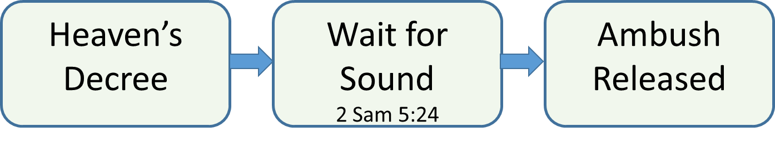
Hillary’s great reset button for Russia
- Came from Klaus Schwab Covid 19 – the Great Reset
- Didn’t happen because the Ukraine Invasion is the enemy attacking itself (Russia vs the deep state)
- Putin is Klaus Schwab trained just like Hillary, he is fighting with his own team!
Decree – Safety of God’s people in Ukraine, preserve them, shield them, a hedge of protection
Decree – Safety, prosperity of US during transition (Awakening); Release Exposure, Justice for all

Wisdom
Father is releasing books of purpose, assignments for Ezekiel’s army of Sons
- people will know their purpose, do their exploits
- miraculous intervention flows with Co-laboring on the same purpose (doing what Father is doing)

Understanding
Tactics – wait for the sound of marching
Sons don’t wait, They go and “see” in the courts and council; wait for timing, not direction
The season of spiritual warfare without courts and council is ending. no longer optional for sons
Three things are happening
- I am pulling the curtain back, Sons who ascend have discernment of what is happening.
- They are releasing decrees, setting ambushes
- They are preparing for a victory; the tipping point is past (see a bright, Kingdom future)

Counsel
I have given you a trumpet – Make the sound
- of the Kingdom of heaven on Earth
- Let sons be in their seats in the council
I am giving you new authority and clarity. You are breaking books out of their glass cases (Religion). It is a ministry of love, and respect, and warfare.

Might
I have giving you keys to break the spirit of Leviathan by hearing books and people
- Intellectual pride (Leviathan) will not strangle my Spirit
- Call them into their hearts, their heroism, their story
- Challenge them to strength and courage
- Call for the Joshua’s and the Caleb’s to take their land

Knowledge
Give the keys to the Kingdom to others; open doors, show them how
Scene – Doors into their store house of Heaven’s provisions, ideas, creativity, ownership. Aisles full of ‘all things.’
Fear of the Lord
John - Father is honored when you pull sons into their books
- It is worship
- All of heaven celebrates when it happens
There is a jail break of momentum, freedom than can be felt
- Help people set aside their fear of the enemy’s little plans, to see the glory of their Father’s plan
- Help them run with the horses of heaven
- Help them taste and see… the glory, the banquet, the excitement, the worship

Where? can you see the spirit of this movement:
- Reawaken America Events + Clay Clark interview
- Alternative news exposing the cabal on Telegram, Rumble
  - Devolution - https://rumble.com/c/c-1102531
  - Khazarian Mafia (KM) History
  - Prussia Gate - https://prussiagate.substack.com/
  - Steve Bannon - https://web.telegram.org/z/#-1250848320
  - Pete Satilli - https://web.telegram.org/z/#-1175859683
  - Truth Social App when it goes up - https://truthsocial.com/
- Prophetic – Johnnie Enlow, Steve Schultz, Praying Medic, Dutch Sheets

